Inspection Date | 6-6-2022 | Report Ref. No. | MACINS 49-6/6/2022
Site Name | Main Campus | Location | Environmental Lab C01025
Inspected By | Hend Alzaabi & Roberto | Witnessed by

Inspection Type | ◻General ◻Housekeeping & Sanitation ◻Fire ◻Electrical ◻Ladders ◻Lab ◻Food ◻Structure ◻Motor Vehicles ◻Landscaping ◻PPE ◻Stores ◻Emergency Evacuation

Findings
 | ◻ Safety ◻ Environment ◻ Occupational health
S/N | Description | Significant Risk  Yes/No | Risk Evaluation
S/N | Description | Significant Risk  Yes/No | Low | Med | High
 | Chemicals found on the floor
 | The emergency contact number needs to be updated.
 | Access to the first aid kit was found hindered.
 | Oven found with no safety signage (hot surface warning sign).
 | Chemicals were found stored in the shelf.
 | Empty combustible cartoon boxes were found in the lab.
 | Carton boxes and items found stored under the bench
 | 2 pin electrical plug without earthing found in the Lab
 | Old emergency first aider names found in the lab
 | Safety Door signage details not available

Attachment | ◻Photos ◻ Video Footage ◻Other

Corrective actions
S/N | Description
 | Short Term Action |  | Long Term Action |  |  |  | By Whom |  |  |  | By When
 | Chemicals need to be stored in a secondary container. |  |  |  |  |  | Lab in charge |  |  | 6-7-2022
 | Old existing emergency contact number list to be updated and posted on the door |  |  |  |  |  | Lab in charge |  |  | 6-7-2022
 | First aid kit needs to be relocated. |  |  |  |  |  | Lab in charge |  |  | 6-7-2022
 | safety signage need to be available in all equipment |  |  |  |  |  | Lab in charge |  |  | 6-7-2022
 | Chemicals need to be stored and secured in the chemicals cabinet |  |  |  |  |  | Lab in charge |  |  | 6-7-2022
 | Combustible carton boxes need to be removed |  |  |  |  |  | Lab in charge |  |  | 6-7-2022
 | Items need to be stored appropriately. |  |  |  |  |  | Lab in charge |  |  | 6-7-2022
 | 2 pin electrical plug need to be replaced with an approved 3 pin. |  |  |  |  |  | Lab in charge |  |  | 6-7-2022
 | Emergency First aiders names need to be updated |  |  |  |  |  | Lab in charge |  |  | 6-7-2022
 | Safety Door signage details need to be available |  |  |  |  |  | Lab in charge |  |  | 6-7-2022
Prepared by: ESH Section |  |  |  | Received by: |  |  |  |  | Followed up by:
 |  |  |  | Contractor: |  | Consultant: |  |  | ◻ Corrective Action is taken |  |  | ◻ Corrective action not taken
Name |  | Hend |  | Name |  | Name |  |  | Name
Designation |  |  |  | Designation |  | Designation |  |  | Designation
Signature |  |  |  | Signature |  | Signature |  |  | Signature
Date |  | 9-6-2022 |  | Date |  | Date |  |  | Date

Attached Photos

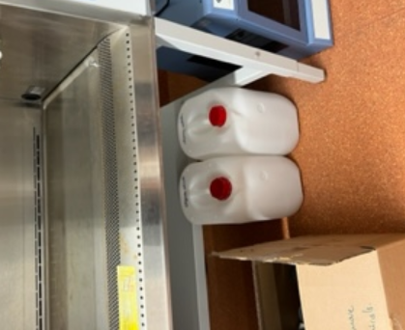 | 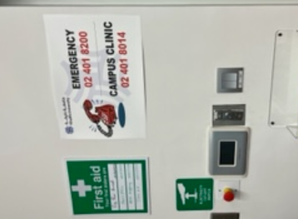
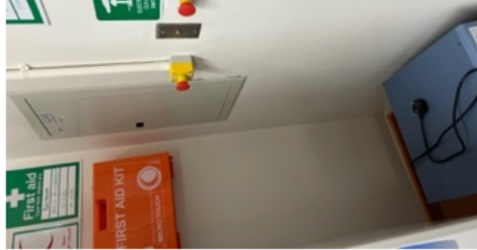 | 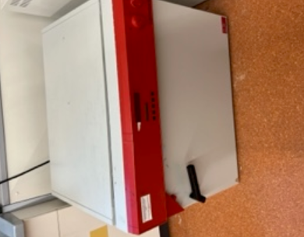
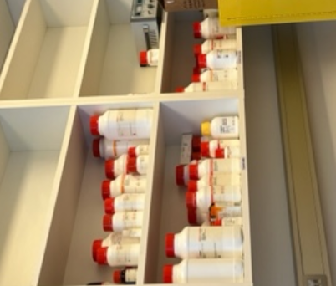 | 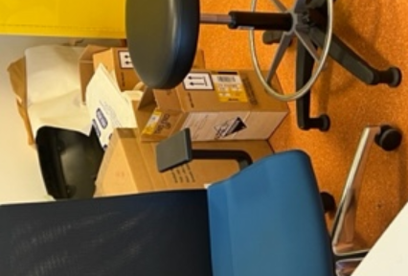
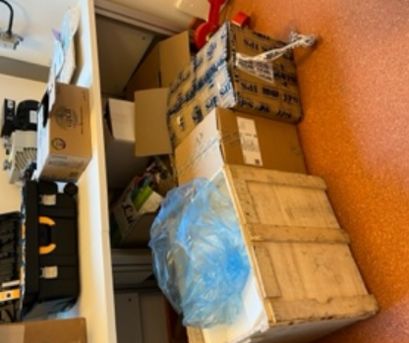 | 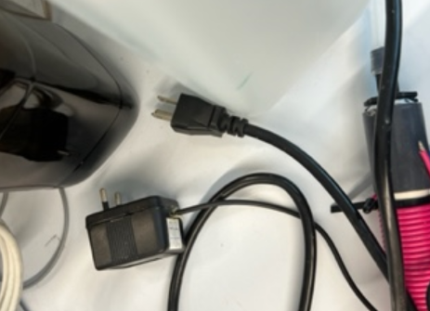
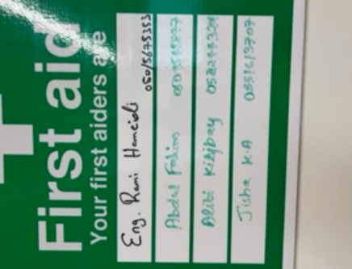 | 